Practical 9: Graph Traversal: Depth-First Search and Breadth-First Search
Practical Aim
To implement depth-first and breadth-first traversal on a graph and develop the ability to reason about how the order of exploration changes depending on the traversal strategy used.
Problem 1
A disaster relief team needs to inspect all buildings in a city after an earthquake. The city is mapped as a network where buildings are connected by roads. One team starts at a building and goes as deep into each road as possible before backtracking, while a second team spreads out level by level — first checking all buildings directly connected to the start, then all buildings two roads away, and so on. Given the city map as a graph and a starting building, implement both exploration strategies and print the order in which buildings are visited by each team.
Describe how the order of buildings visited differs between the two strategies on the same graph. What data structure does each strategy rely on to decide which building to visit next, and how does that structure cause the difference in order?
Code
https://github.com/AD-9218/DATA-STRUCUTURE-AND-ALGORITHM/blob/main/Practical-9/9_1.cpp
Output
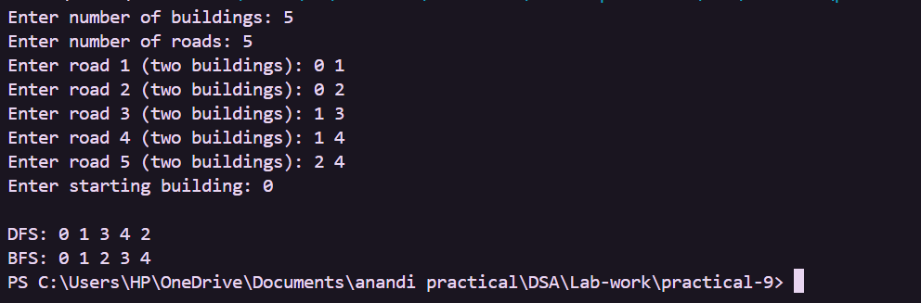
Key Questions / Analysis / Interpretation
1. [Problem 1] Both strategies visit every reachable node exactly once. If the goal is simply to check whether a specific building exists in the network, which strategy would find it sooner if the building is very close to the start? What if it is very far and deep? Explain your reasoning without tracing through a specific example.
Answer: If the building is very close to the start, BFS is generally more likely to find it sooner because it explores nodes level by level. If the building is very far and lies deep along one path, DFS may reach it sooner because it explores deeply before backtracking. The actual order can still depend on the graph structure and the order in which adjacent nodes are processed.
2. [Problem 1] Your DFS implementation likely uses recursion. What real-world constraint on the computer could cause your recursive DFS to fail on a very large city map, and how would you restructure your solution to avoid that failure?
Answer: A very large or very deep graph can cause too many recursive function calls and overflow the call stack. To avoid this, DFS can be implemented iteratively using an explicit stack instead of recursion. The stack stores the nodes that still need to be explored, so the traversal does not depend on the computer's recursive call stack.

